Research Report and Design Planning

Group Project

## by YULIIA ANTONOVA C00301432@SETU.IE

## SOLOMIYA DATSKIV C00301892@SETU.IE

## SOFIIA PANKIV C00301189@SETU.IE

IDAD Y2 | Web User Interface Design | January-February 2025

# Topic Selection and Research of Existing Websites

**The topic of our website research is shopping: a website for buying and selling original artworks.**

**Our Target Audience:**

* Art enthusiasts and collectors.
* People looking for unique gifts.
* Interior decorators and designers.
* Buyers who appreciate handmade craftsmanship and artistic style.

## Websites We Will Analyze Based on Key Criteria:

### For Buying and Selling Original Artworks:

1. **Etsy**  
   A platform for selling unique handmade works: paintings, sculptures, posters, and other artworks.
2. **SaatchiArt**  
   An international online marketplace where artists can sell paintings, photographs, and sculptures directly to buyers.
3. **Artfinder**  
   A platform offering original artworks: paintings, prints, and drawings from independent artists.
4. **Artsy**  
   A platform connecting galleries, auction houses, and artists to sell both contemporary and classic artworks.
5. **Singulart**  
   A platform where artists can sell their works, targeting the international market.

## Other Important websites that meet the topic:

### For Digital Art and NFTs:

1. **Foundation**
2. **OpenSea**
3. **SuperRare**

### For Auctions:

1. **Sotheby’s**
2. **Christie’s**

### Social Platforms for Artists:

1. **DeviantArt**  
   **Behance**

## ETSY WEBSITE Analysis

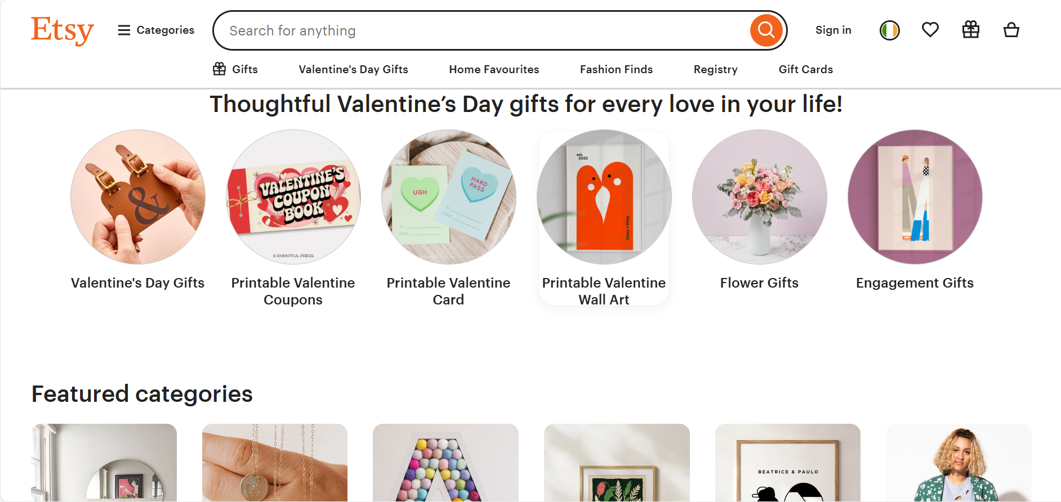

### 1. User-Friendliness

Etsy’s interface is intuitive and simple for both buyers and sellers. buyers to navigate categories like jewelry, art, and home decor with ease. Key functions such as search and filters enhance the shopping experience, and the checkout process is seamless.

For sellers, Etsy offers useful tools for shop setup and sales analytics. However, new sellers may find the setup process overwhelming due to numerous configuration options.

### 2. Responsiveness

Etsy is fully optimized for mobile devices. The app is well designed, and it mirrors the desktop experience. Pages load quickly, ensuring smooth navigation.

* Mobile performance is very strong, but occasional discrepancies exist between desktop and mobile seller tools.

### 3. Accessibility

Etsy supports multiple languages and currencies, making it accessible to a global audience. It follows accessibility standards, offering screen reader compatibility.

* Inconsistent return and exchange policies per seller can create confusion for buyers.

### 4. Aesthetics

Etsy’s minimalist design, neutral color palette, and structured layout ensure a visually appealing user experience. Product pages are well organized with clear descriptions and reviews.

### 5. Content Quality

Most sellers provide detailed descriptions and high-quality images, which enhance buyer confidence. The transparent review system allows for informed purchasing decisions.

* Some listings suffer from poor descriptions and low-quality images.

### 6. Interactivity

Etsy enables buyers to favorite items, leave reviews, and communicate with sellers. Sellers have access to analytics, advertising, and store customization tools. The platform fosters a sense of community through forums and educational materials.

* The chat function depends on seller response times, which can lead to delays and frustration for buyers needing quick assistance.

### 7. Consistency

Etsy maintains a uniform experience across desktop, mobile, and app versions. Its branding remains cohesive, and essential functions like search and filtering operate consistently.

* Some seller tools are limited to desktop, and inconsistencies in product presentation—due to varying seller content quality—can impact overall platform uniformity.

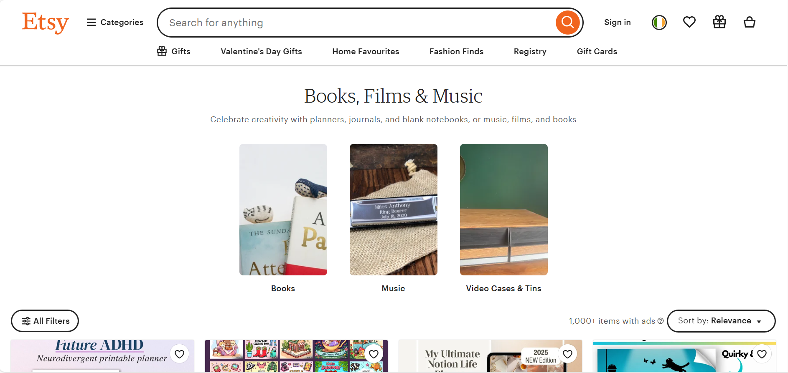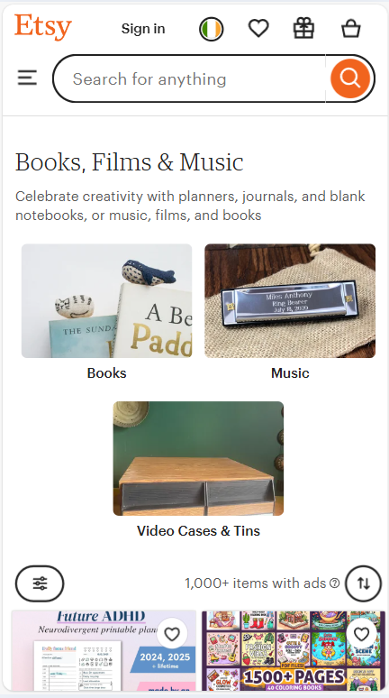

### **Overall Rating: 4.5/5**

Etsy is a top-tier platform for unique products, excelling in user-friendliness, aesthetics, and interactivity. However, improvements in seller onboarding, content quality control, and response time for buyer inquiries could further enhance the experience.

## SAATCHI ART WEBSITE ANALYSIS

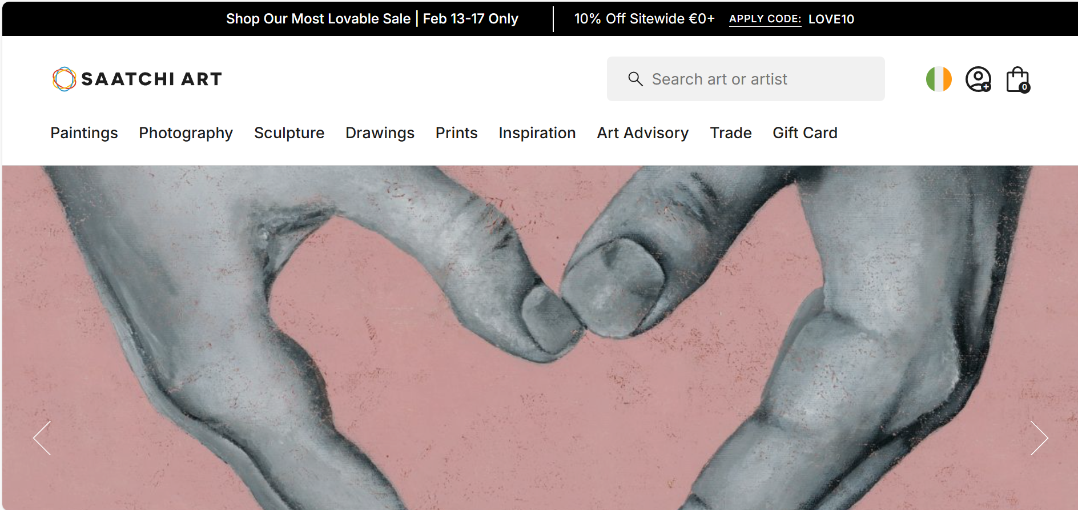

### 1. User-Friendliness

Saatchi Art’s interface is perfect for art enthusiasts, offering a clean and intuitive layout. Users can easily browse categories like paintings, photography, and sculptures, with a structured filter system for refined searches. The purchase process is straightforward, and artists have access to tools for profile setup and sales tracking.

* The extensive profile setup may be overwhelming for new artists due to the amount of required information.

### 2. Responsiveness

The website is mobile-friendly, with well-scaled images and filters. Pages load quickly, ensuring smooth navigation.

* The lack of a dedicated mobile app limits accessibility for users who prefer app-based browsing and purchasing.

### 3. Accessibility

Saatchi Art supports multiple currencies but is only available in English, restricting accessibility for non-English speakers. It adheres to basic accessibility standards, such as keyboard navigation and screen reader support.

* Expanding language options would make the platform more inclusive for a global audience.

### 4. Aesthetics

The website features a minimalist design with a neutral color palette that keeps the focus on the artworks. Galleries and product cards are well-structured, offering a professional and immersive browsing experience.

* While the design is visually appealing, more personalization options could enhance user engagement.

### 5. Content Quality

Each artwork listing includes detailed descriptions, high-quality images, and artist biographies. Some artworks feature in-room previews for better visualization.

* The absence of a review system makes it difficult for buyers to gauge artist reputation. Additionally, shipping and return details are sometimes vague, leading to uncertainty for buyers.

### 6. Interactivity

Users can favorite artworks, create collections, and follow artists. Artists benefit from promotional guidance and analytics. The platform also offers a blog with curated content and interviews.

* Direct communication between buyers and artists is limited, reducing opportunities for customization or commissioned work.

### 7. Consistency

Saatchi Art maintains a cohesive design across all pages, with standardized product listings and artist profiles. Core navigation features function consistently across desktop and mobile versions.

* The lack of a mobile app affects cross-platform consistency, and the limited buyer-artist communication reduces the sense of personalized service.

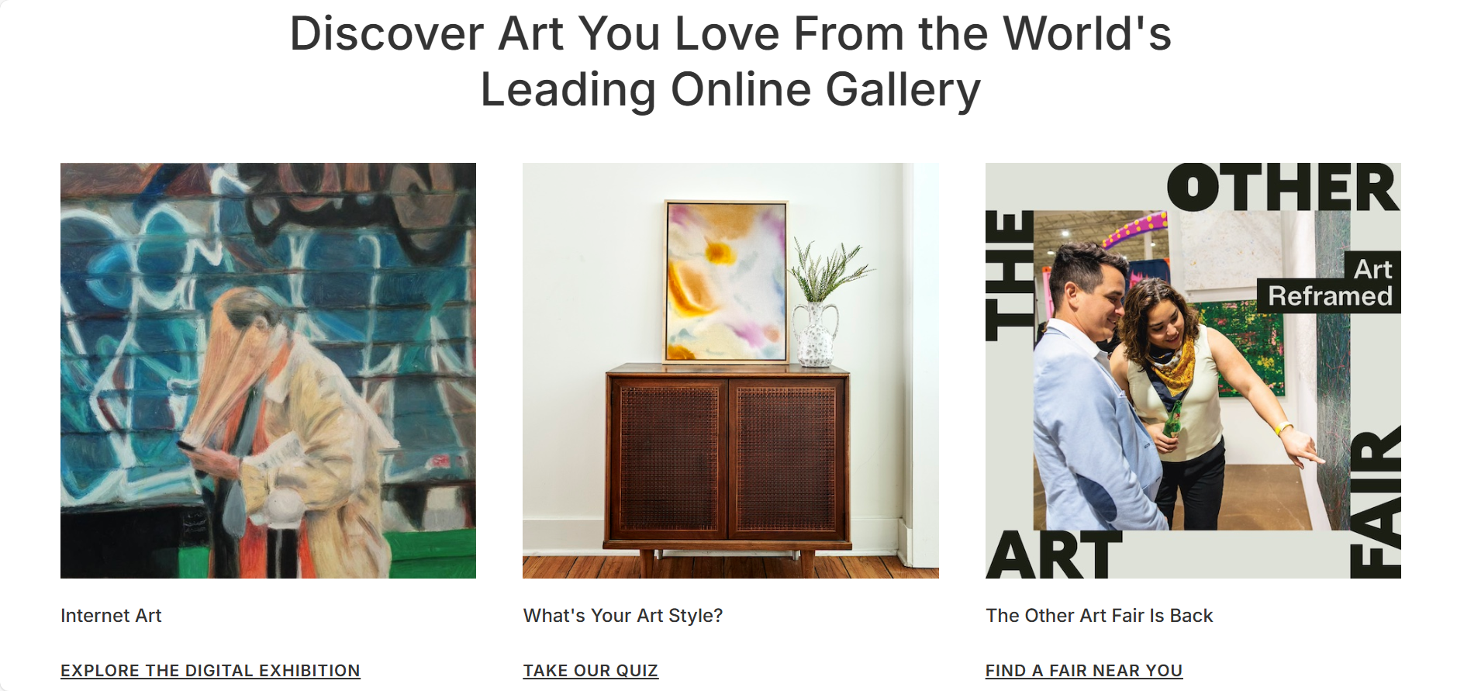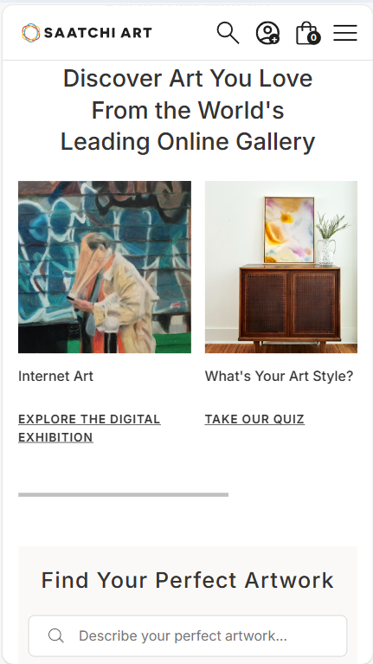

### **Overall Rating: 4.5/5**

Saatchi Art offers a polished and professional platform with a strong emphasis on aesthetics and usability. However, adding a mobile app, multilingual support, and a review system would significantly improve the overall user experience.

## Artfinder WEBSITE Analysis

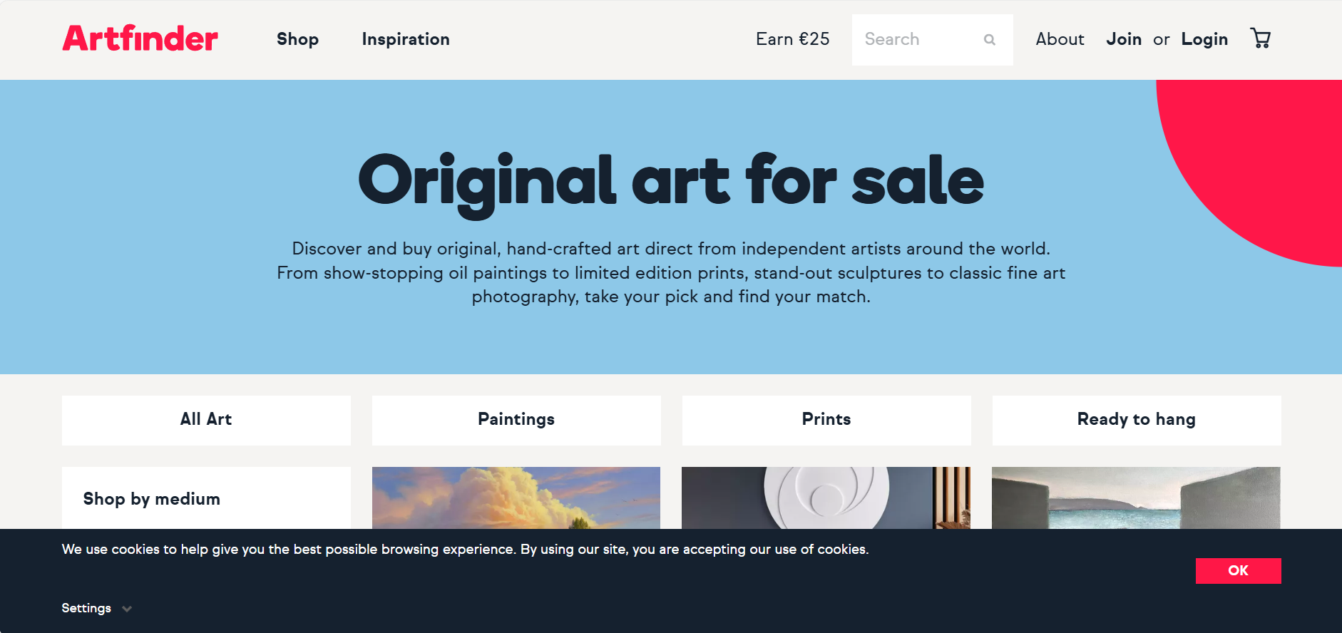

### 1. User-Friendliness

Artfinder’s interface is well-organized, offering easy navigation through categories like paintings, sculptures, and photography. Filters allow users to refine searches based on style, material, and even mood. The checkout process is simple, providing clear pricing and shipping details.

* Additionally, competition among artists is high, making visibility a challenge.

### 2. Responsiveness

The website is fully optimized for mobile devices, with all key functions working smoothly. Pages and images load quickly, ensuring a seamless browsing experience.

### 3. Accessibility

Artfinder supports multiple currencies and global shipping. The site follows basic accessibility standards, offering screen reader compatibility and keyboard navigation.

* The platform is only available in English, which restricts accessibility for non-English speakers.

### 4. Aesthetics

Artfinder maintains a minimalist design, using a white background and neutral tones to emphasize artworks. Product galleries are well-structured, creating a professional and immersive experience.

* The aesthetic is clean and appealing, but more interactive design elements could improve engagement.

### 5. Content Quality

Each artwork listing includes detailed descriptions, artist biographies, and high-quality images, sometimes with in-room previews. The review system helps buyers assess artists and their service quality.

* Some descriptions lack depth, as content quality depends on individual artists. A more standardized approach could improve consistency.

### 6. Interactivity

Users can save favorite artworks, follow artists, and receive personalized recommendations. Artists have access to promotional tools and marketing advice. The platform also features a blog with curated selections and buying tips.

* The absence of direct buyer-artist communication limits order customization and the potential for commissions.

### 7. Consistency

Artfinder maintains a uniform design and navigation structure, ensuring a seamless experience across devices. Search functions, product listings, and checkout processes follow a standardized format.

* The lack of a mobile app disrupts cross-platform consistency, and the absence of multilingual support hinders accessibility for a broader audience.

### **Overall Rating: 4.5/5**

Artfinder is a polished and professional platform for original art, with strong aesthetics and usability. However, adding a mobile app, multilingual support, and enhanced artist visibility tools would significantly improve the user experience.

## ARTSY WEBSITE ANALYSIS

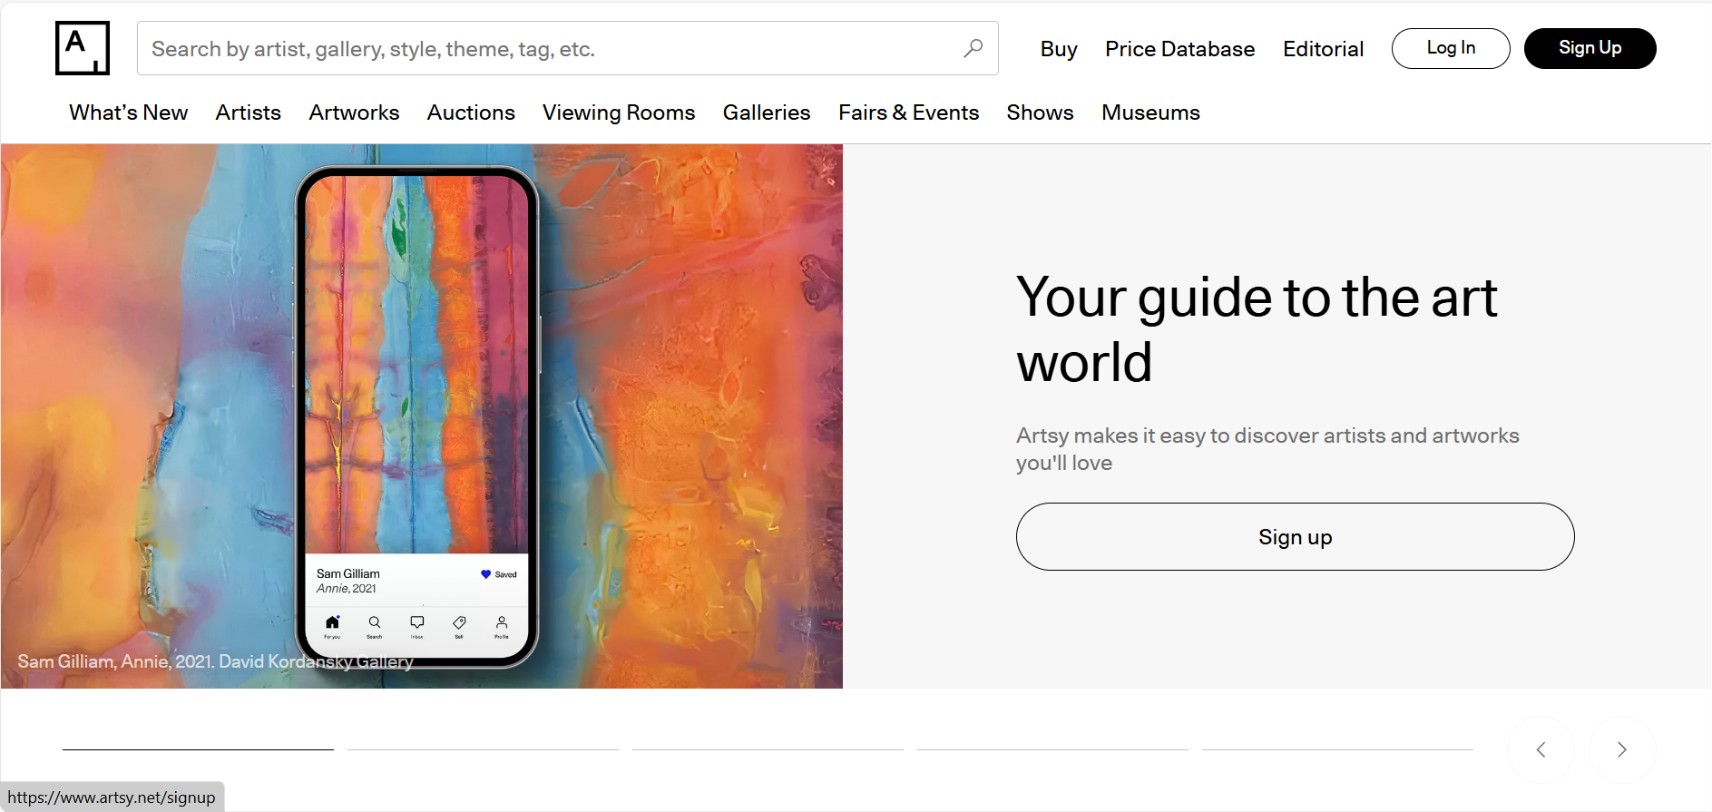

### 1. User-Friendliness

Artsy offers a professional interface, with a homepage that highlights key sections like Auctions, Galleries, and Artists. Navigation is well-structured, allowing users to filter artworks by style, price, size, and location. The purchase process is intuitive, integrating auctions, gallery sales, and direct purchases.

* The platform is tailored for art professionals, which may make it less accessible for beginners.

### 2. Responsiveness

The website is fully optimized for mobile, maintaining full functionality across devices. Artsy also offers an iOS app with access to all major features, including auctions. Despite the visual-heavy content, loading speed is fast due to optimized images.

* The absence of an Android app limits accessibility for a broader audience.

### 3. Accessibility

Artsy supports multiple currencies for international transactions but is available only in English. The platform follows basic accessibility standards but is primarily designed for a visually engaged audience.

* The lack of multilingual support may limit accessibility for non-English speakers.

### 4. Aesthetics

The platform's modern and sophisticated design enhances its gallery-like feel. A neutral color palette ensures that artworks remain the focal point, while structured layouts provide a seamless browsing experience.

* Adding more interactive elements could enhance engagement.

### 5. Content Quality

Each artwork listing includes detailed descriptions covering the artist, materials, and historical context. High-resolution images with zoom functionality enhance the viewing experience. Additionally, Artsy provides educational content, including articles, curated collections, and artist interviews.

* Some rare or unique pieces may lack sufficient background information.

### 6. Interactivity

Buyers can participate in auctions, save favorite artworks, and receive personalized recommendations. Artists and galleries have access to promotional tools, analytics, and client connections. The platform also engages users through newsletters and personalized content.

* Limited direct communication between buyers and sellers reduces the potential for order customization and direct negotiations.

### 7. Consistency

Artsy maintains a cohesive user experience, with a minimalist design and uniform navigation structure across web and mobile platforms. The checkout process remains standardized, whether purchasing from a gallery, auction, or direct sale. Filters and personalization work consistently across sections.

* The lack of multilingual support disrupts accessibility for international users. Also, users are not able to communicate directly with sellers.

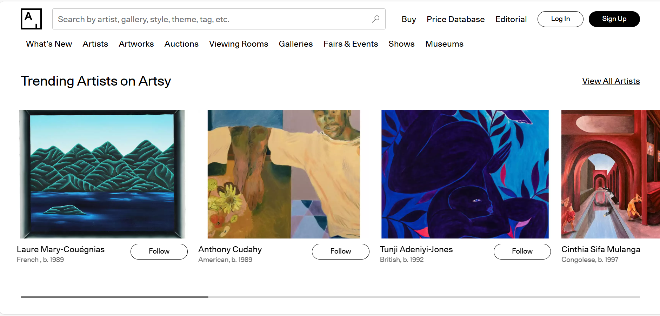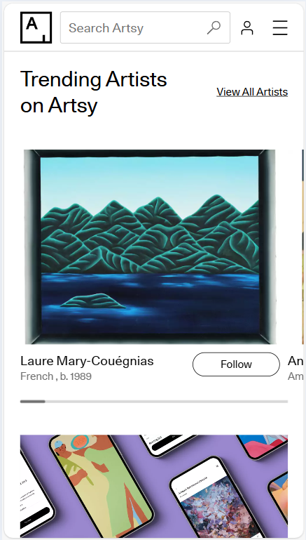

### **Overall Rating: 4.6/5**

Artsy is a high-quality platform for art collectors, galleries, and enthusiasts, offering strong design consistency, functionality, and educational content. However, adding multilingual support, direct buyer-seller communication, and an Android app would significantly enhance accessibility and user experience.

## Singulart WEBSITE Analysis

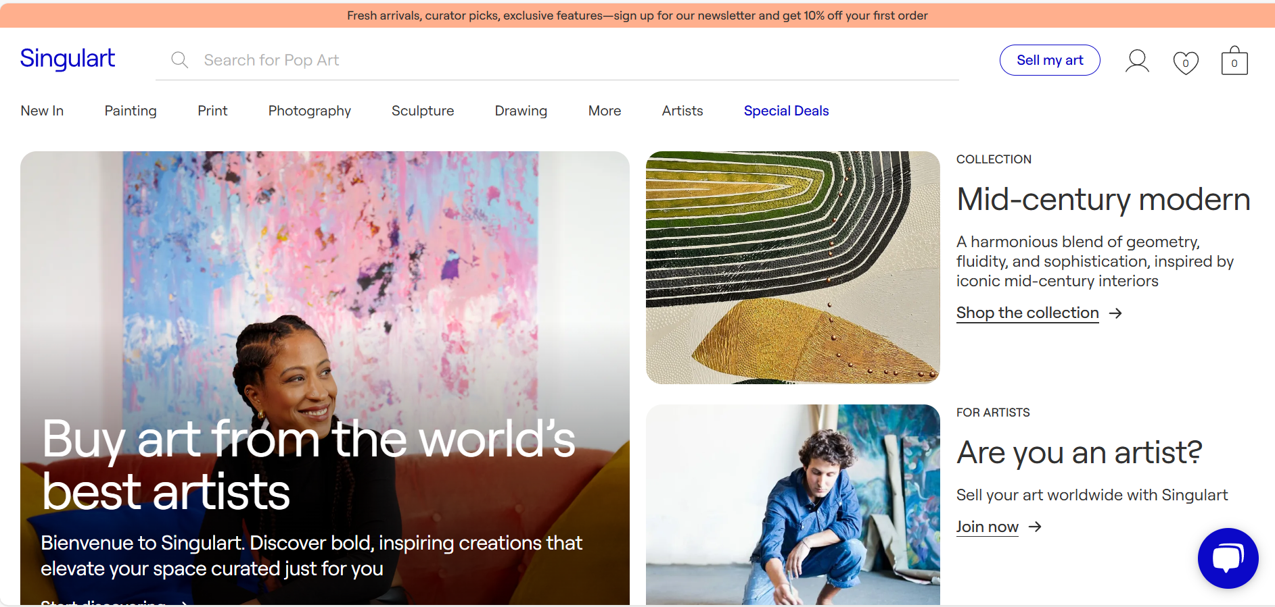

### 1. User-Friendliness

Singulart offers an elegant and intuitive interface, with a homepage that highlights key categories like "Paintings," "Sculptures," and "Photography." Navigation is user-friendly, allowing searches by style, materials, size, price, and color. The platform caters to collectors and corporate buyers with dedicated sections.

The checkout process is structured and includes access to customer support. Artists benefit from an easy artwork upload system, but registration is selective, focusing on high-level professionals.

* The complexity of the platform may be challenging for beginners, both artists and buyers.

### 2. Responsiveness

The website is fully optimized for mobile devices, maintaining both functionality and aesthetics. Pages and images load quickly, ensuring a seamless browsing experience. However, Singulart does not offer a dedicated mobile app, which may be a drawback for users who prefer app-based interactions.

### 3. Accessibility

Singulart supports multiple languages (including French, English, and German) and offers various currency options for international payments. It follows basic accessibility standards, including keyboard navigation and screen reader support.

* While the platform is multilingual, some translations lack accuracy.

### 4. Aesthetics

Singulart’s minimalist design keeps the focus on the artworks, using a white background and neutral colors for a professional look. Galleries are well-structured to present artworks effectively, with clear displays of relevant details.

* The visual presentation is strong, but additional interactive elements could enhance user engagement.

### 5. Content Quality

Each artwork listing provides detailed descriptions, including artist biography, materials, size, and technique. High-quality images allow for detailed viewing, and some artworks are displayed in interior settings for reference. The platform also publishes curated collections and buying guides.

### 6. Interactivity

Buyers can follow artists, add artworks to favorites, and receive personalized recommendations. Artists have access to analytical tools and promotional support. Singulart engages users through newsletters and thematic selections.

### 7. Consistency

Singulart maintains a modern, minimalist design across all sections, ensuring a cohesive user experience. Filters, navigation, and page structures remain uniform across devices. The checkout process is standardized for both personal and corporate purchases. Content, including artwork descriptions and educational articles, follows a consistent format.

* Limited buyer-artist interaction.

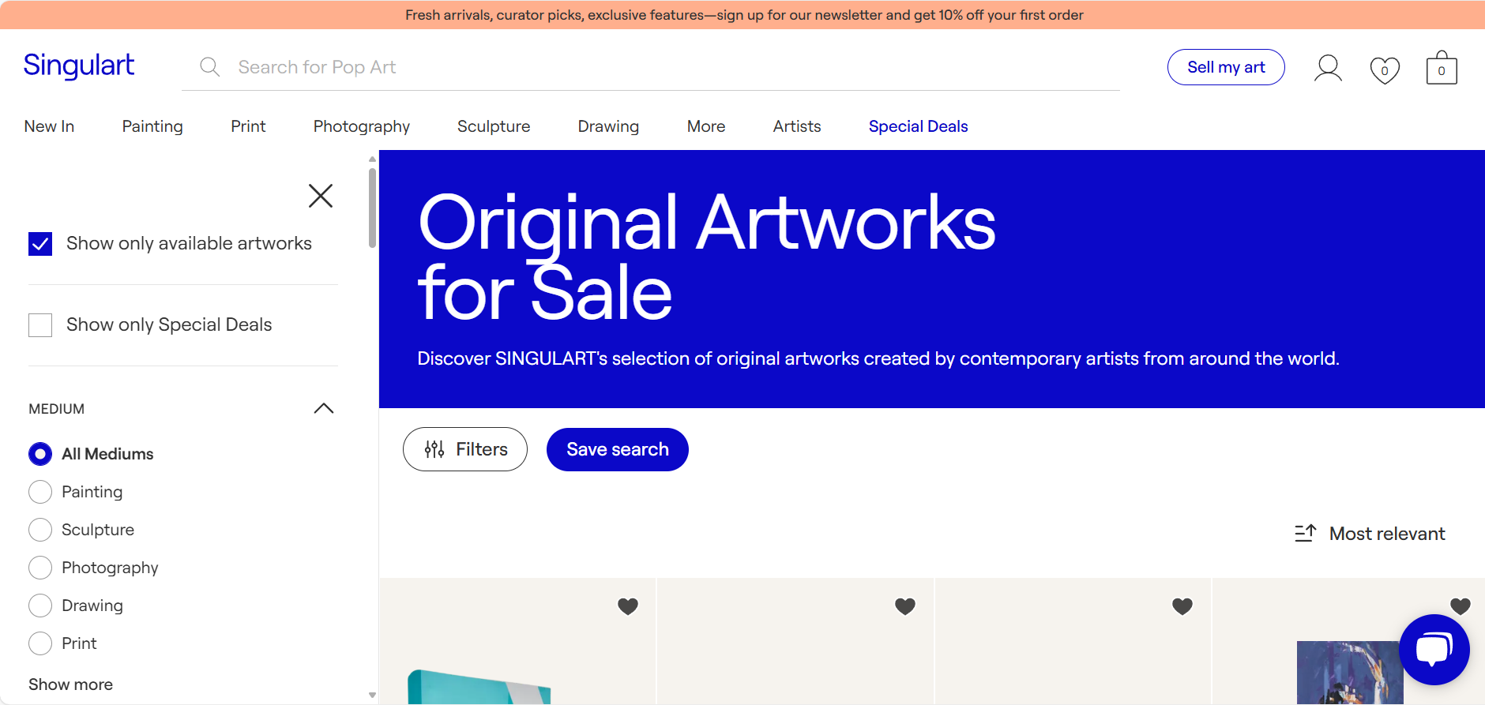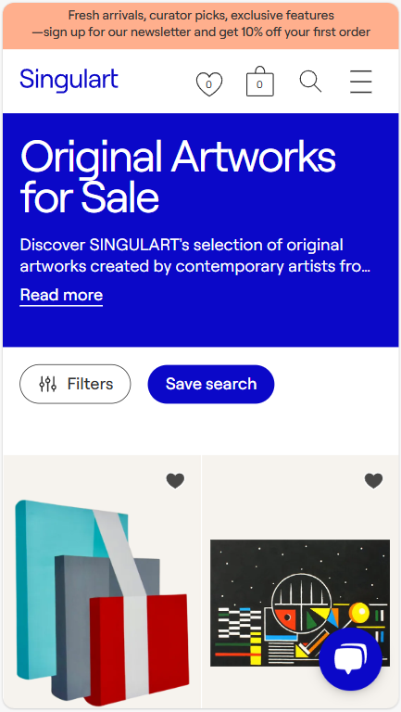

### **Overall Rating: 4.7/5**

Singulart excels in design consistency, international accessibility, and professional presentation. However, improving translation quality would further enhance its global appeal.

# Conduct Audience and Context Research

## User Persona 1

**User Persona:** Emma Taylor, 32, stay-at-home mom

**Demographics:**

Emma Taylor is 32, a stay-at-home mom, a part-time freelance illustrator. She has a Bachelor’s degree in Graphic Design. Emma’s income level is middle-class, she lives in Suburban area with her family, husband and a kid (age 5). Emma is comfortable with technology, and uses smartphones, tablets, and laptops daily for work and in her daily routine.

**Preference:**

Preference in Design Styles:

Emma loves modern, minimalist, and bohemian styles and appreciates unique, handmade, and original artworks.

Preferred Features:

Emma prefers easy-to-navigate websites with clear categories (e.g., paintings, sculptures, wall decor). She often uses zoom to see details of artworks while shopping, so she is happy when websites have high-quality images with zoom functionality. Emma also finds especially useful filters for price range, size, color, and artist; Wishlist and save-for-later options. She pays a lot of attention to customer reviews and artist bios and appreciates mobile-friendly design for browsing on the go.

Content Interests:

Emma is interested in blogs on styling artworks in home spaces, themed collections (e.g., holiday decor), she also loves to read stories about artists and their creative processes.

**Goals:**

Primary Goals: Find original works of art for decoration that are unique; Be able to compare prices and styles with ease to fit your budget; Feel secure in purchasing items; Independently support the artists and/or small businesses.

Secondary Goals: Discover new artists or trends in home decoration; Save time by getting what she is looking for ASAP.

**Frustrations:** poor mobile usability; confusing navigation; unclear product details; shipping and return issues; lack of personalization:

Emma gets frustrated with websites that are not optimized for mobile, slow loading times. She can get overwhelmed because of cluttered website layouts and complicated forms and return policies for merchandise like artworks.

**Scenario for the Activity**

Task: Emma is looking for a large abstract painting in neutral tones with blue accents to hang above her living room sofa. Her budget is $200–$500. She wants to browse quickly, compare options, and make a secure purchase.

### Simulated Interactions with Art Websites

Steps:

1. Search for " Abstract Art " in the search bar

2. Filters applied: Size-large, Color-neutral tones, blue accents, Price-$200-$500

3. Saved Favorites, and compared similar artwork

4. Read the customer reviews and check for shipping details.

4. Proceeded to check out and checked options for payment

**1. Etsy Observations:**

It was easy to use the filters and quickly narrow down the options; customer reviews gave great confidence in the quality of the artwork.

Shipping costs were unclear until the final checkout step.

Improvements: Earlier display of shipping costs.

**2. SaatchiArt Observations:**

Filters were easy to work with, artist bios added personality and made a piece of art unique.

The "View in Room" feature was not available for all artworks.

Suggestion: Provide "View in Room" feature for all artworks.

**3. Artsy Observations:**

The website had a great deal of details about the artists and exhibitions; filters were well-implemented and easy to apply.

Contacting the gallery for purchase might be indirect and slow, which is the case for some artworks without clear price information.

Suggestion: Add to the site the possibility of direct purchase of artwork with clear pricing.

**4. Artfinder Observations:**

The "View in Room" feature was very helpful, and the filters were intuitive and effective.

Sometimes the website would lag when using the "View in Room" feature.

Improvements: Make the "View in Room" feature smoother.

**5. Singulart Observations:**

The comparison feature was nice to evaluate similar artwork; payment options were very clear and secure.

The layout of the website was somehow messy on mobile, and some filters were hard to find.

Improvements: Make the mobile layout more navigable, make filters more salient and accessible.

**Assess the Access Environment**

If peers access websites while walking around on their smartphones, we can witness the following: small text difficult to read on Artsy, buttons too small to tap accurately on Singulart, menus hard to access on Etsy.

**Evaluate the Target Audience’s Tech Proficiency**

Questions to Consider: Emma is tech-savvy, but she prefers simplicity due to her busy schedule. She needs a simplified interface, large buttons, clear labels, and minimal clutter would improve her experience.

Activity:

Tech-Savvy User: Applies multiple search filters and uses advanced features like "View in Room."

Novice User: Concerned with simple tasks such as locating the homepage and help resources. Suggestions: The navigation bar is too crowded. Clear labeling, with a 'Help' section that stands out.

**Documenting Insights**

Persona-based insights: Emma struggled to compare artworks side by side on most websites. She recommended a 'compare' feature that would allow her to assess similar pieces. On SaatchiArt, she enjoyed reading the bios of the artists but wanted more styling tips.

Context-Based Insights: Mobile users can find the websites challenging to navigate due to small-sized menu icons, or perhaps text overlapping at smaller displays. Beginners need clear labels on buttons and a 'Help' tab explicitly to walk them through tasks like filtering and checkout.

## User Persona 2

### **User Persona:** Fred, 67, Collector.

**Demographics:**Fred is 67 years old, old-school man. He has education in economy sphere, but he was always collecting some interesting art and helps young artist by investing in their art. Since he was retired, he had more time to learn more about art pieces and collect pieces he liked and valued.

**Preference:**

Preference in Design Styles:

Fred prefers minimalism and simplicity in websites and appreciate unique artworks which can accomplished his collection.

Preferred Features:

Fred prefers simply looking sites with clear and easy navigation through it, transparent pricing and fees which could be seen as soon as possible because usually customers either don't notice or notice at the last moment before payment. He likes the site with hight-quality photos and clear description of every artwork to be able to see exactly how the art looks like, and it would help him to decide what art piece he wants to buy.

Content Interests:

Fred is interested in collecting artworks he finds unique to supplement his own collection.

**Goals:**

1. **Discover new artists** – Fred wants to explore fresh talent and unique pieces that could appreciate.
2. **Find clear and transparent pricing** – He needs clear costs without hidden fees.
3. **Easily compare artworks** – Prefers simple search tools to compare pieces efficiently.
4. **Make seamless purchases** – A quick, secure buying process is essential.
5. **Quote**: - “I love Art and supporting young talents”.

**Scenario for the Activity**

Task: Fred is searching for something that can be added to his collection. He needs to spend some time in front of computer without any hurry to find exact masteries he would be happy with.

### Simulated Interactions with Art Websites

1. Check filters (or if there is a possibility to press the button “What’s new” which supposed to show new art that was published.

2. Check every aspect of artwork that he likes and read the description with some information about the artist.

3. Saved a few items to the Wishlist

5. Attempted checkout

**Feedback:**

**Etsy** is a good site for finding some interesting handmade stuff and art. It has simple checkout and good search functionality with categories and subcategories. But it has too much clutter and unrelated recommendations, unclear prices because of additional shipping costs and some descriptions are poor or quiet incorrect what can confused customers.

**Etsy** might feel overwhelming for Fred due to the vast number of items and varied seller quality. It may not be the best fit for high-end art collection.

For improvements for this site needs to clear prices showing the price of shipping price next to the art piece.

**Artfinder** and **Saatchi Art** is a site with a large selection of original artworks with a lot of information about the art piece, but there can be some issues for customers with overwhelmed interface and design of site and prices inconsistencies.

Fred finds **Artfinder** and **Saatchi Art** appealing due to their vast selection of emerging artists and clear pricing, though Saatchi Art can feel overwhelming. While both platforms offer quality curation, he struggles with occasional slow loading times and complex navigation.

To improve these sites, it would be nice to have a more structured portfolio of artists, clearer prices and enhance the virtual review to see how art looks from different settings.

**Artsy** and **Singulart** are nearly perfect for customers who are searching for valued piece of art. There is a lot of high-end and investment-grade art pieces, auction-style buying options, detailed artist profiles and provenance, strong focus on contemporary and emerging artists which are good qualities for customers. There are disadvantages too like limited selection compared to larger marketplaces, some artworks require inquiries instead of direct purchases and auctions on **Singular** can be complicated for someone who prefers straightforward buying.

Fred finds **Singulart** and **Artsy** appealing for their curated selection of emerging artists and investment-worthy pieces, with clear artist backgrounds and pricing transparency. However, he sometimes feels overwhelmed by Artsy's auction system and Singulart's limited selection compared to larger marketplaces.

Nice improvements would be if in those sites would be better filters to find emerging artists with investment potential, make a price tracking feature to monitor changes over time.

## User Persona 3:

**Michel, 35 years old, artist**

А 35-year-old man with two higher education degrees (history and economics) with good computer and internet skills. An amateur artist working in various styles and techniques: acrylic, oil, pencils, pastels, also creating home decorations from foam, fabric and other materials. You are looking to sell your work, and have explored Etsy, Saatchi Art, Artfinder, Artsy, and Singulart platforms.

Etsy may be the most suitable platform. It is geared towards selling both artwork and handmade crafts, which aligns with your profile. The platform offers a user-friendly interface for uploading works and interacting with buyers. Etsy also has a broad audience interested in unique and creative items, allowing to sell both paintings and handmade crafts.

Saatchi Art and Artfinder are good choices to focus on selling paintings. However, their audience is more interested in professional works, and the registration and approval process may be more challenging for artists with a small portfolio.

Artsy and Singulart are geared toward professional artists and galleries, which may limit opportunities for an amateur artist. These platforms require a high level of professionalism and an extensive portfolio.

### Steps Taken to Research the Platforms

* Explored the interface, focused on navigation, store setup options, and the process of adding descriptions and photos of your works.
* Creating a profile.
* Compared terms, analyzed sales commissions, shipping policies, and customer support conditions.
* Evaluating the audience.

### Challenges and Ease of Use

* **Etsy** was easy to set up and upload photos to. Navigation is intuitive, and there are plenty of learning resources for beginners. However, the high competition and the need for active shop promotion can be challenging.
* **Saatchi Art and Artfinder** raised questions about the approval process.
* **Artsy and Singulart** seem complex for a beginner. Their emphasis on professionalism might discourage artists with a small portfolio.

### User Experience

All the platforms mentioned are accessible on mobile devices, allowing you to work on the go. However, Etsy stands out due to its convenient mobile app.

Saatchi Art and Artfinder are also well-adapted for tablets and smartphones, but you might find their interfaces less intuitive.

Artsy and Singulart have a highly professional design, but their navigation and processes can be difficult for non-professionals.

Etsy provides the best conditions for beginners. To promote your paintings, Saatchi Art or Artfinder are great if you have time to build a professional portfolio.

# Project Goals and Objectives

## PROJECT’s Purpose

Creating user-friendly and aesthetically appealing website for selling paintings and handmade crafts, ensuring easy navigation, a seamless ordering process, and providing people an opportunity to find and purchase unique, high-quality works of art.

### Expected User Experience

* Ease and convenience of interacting with the website.
* A sense of exclusivity and personalized service.
* Inspiration and a desire to acquire a unique piece of art.

## Broad Objectives

#### Sections and Content

* **Homepage** – the uniqueness of our platform and the products.
* **Product Catalog** – convenient categorization, filtering by parameters (price, style, materials, etc.).
* **Product Page** – detailed photos, descriptions, seller information, pricing, a "Buy" button.
* **About Us** – brand history, website and art information.
* **Customer Reviews and Stories** – real customer experiences.
* **Contacts and Feedback** – contact form and links.

#### Functionality

* Intuitive navigation.
* Product search and filtering options.
* Online ordering with multiple payment and shipping options.
* Responsive design for optimal viewing on all devices.
* Social media integration.

#### Design Elements

* Elegant style with a focus on visual content.
* Clean interface that highlights the aesthetics of the products.
* Harmony of color scheme.

## Translating goals into user-focused objectives:

**Our goals for the accessible and easy-to-use website are:**

For sellers (artists):

* Simple yet elegant design
* Easy navigation and forms
* Fast notifications with information if someone wants to buy their products
* Interface intuitive and convenient to post artist’s artwork, easy to check the reviews or contact with customers

For buyers:

* Multiple filters to navigate the website
* Categories based on preferences: type of art, artists, price, if needs- gallery
* High quality photos of every art piece from different angle (especially if it’s a sculpture)
* Detailed descriptions of the art piece, information about the artists and galleries
* Contacts and ability to communicate with artists for better buyer/seller connection

### Draft a value proposition:

Our platform will focus on creating enjoyable and useful experiences for all users, both artists who want to sell their creations and customers who want to explore and purchase them. This website will stand out by its comfortable and easy to navigate interface, useful features, professionalism and consistency. We will provide not just a shopping website, but an aesthetically pleasing and accessible platform for buying and selling original art. We want to make our webpage a space designed for creative, artistic people and make it easy to use for everyone, beginners and professionals.